**3-tier application using azure virtual machines**

1. Created two Virtual machines with availability set using azure portal.And validated both VM’s and able to login successfully.
2. And configured both VM’s under same VNet. And configured the NSG rules with ports(3389, 80(HTTP), 443(HTTPS))

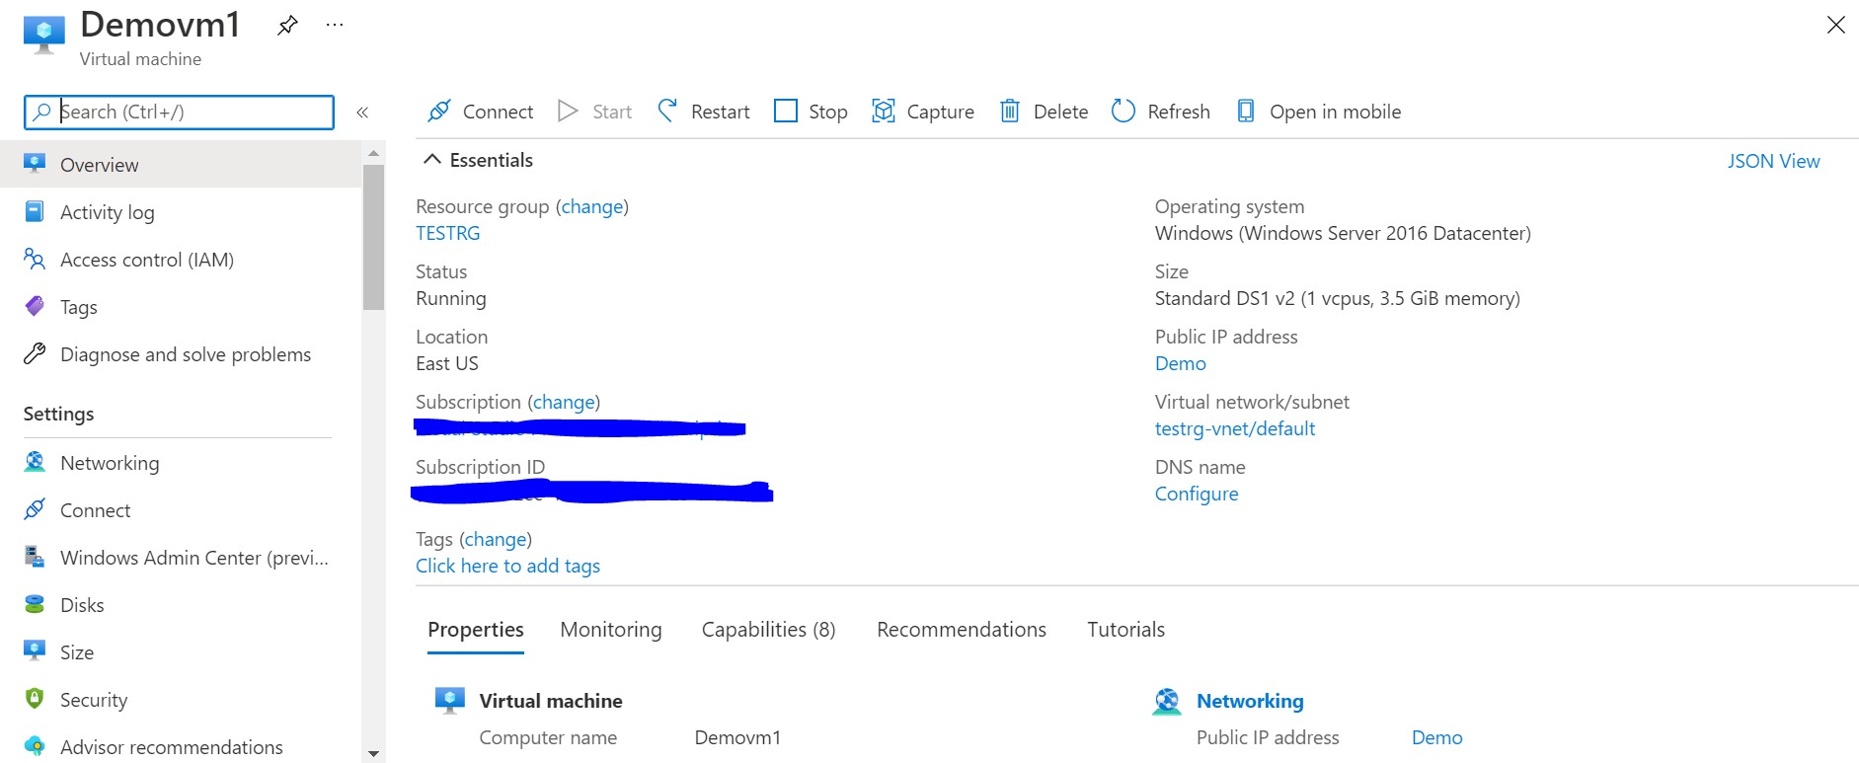

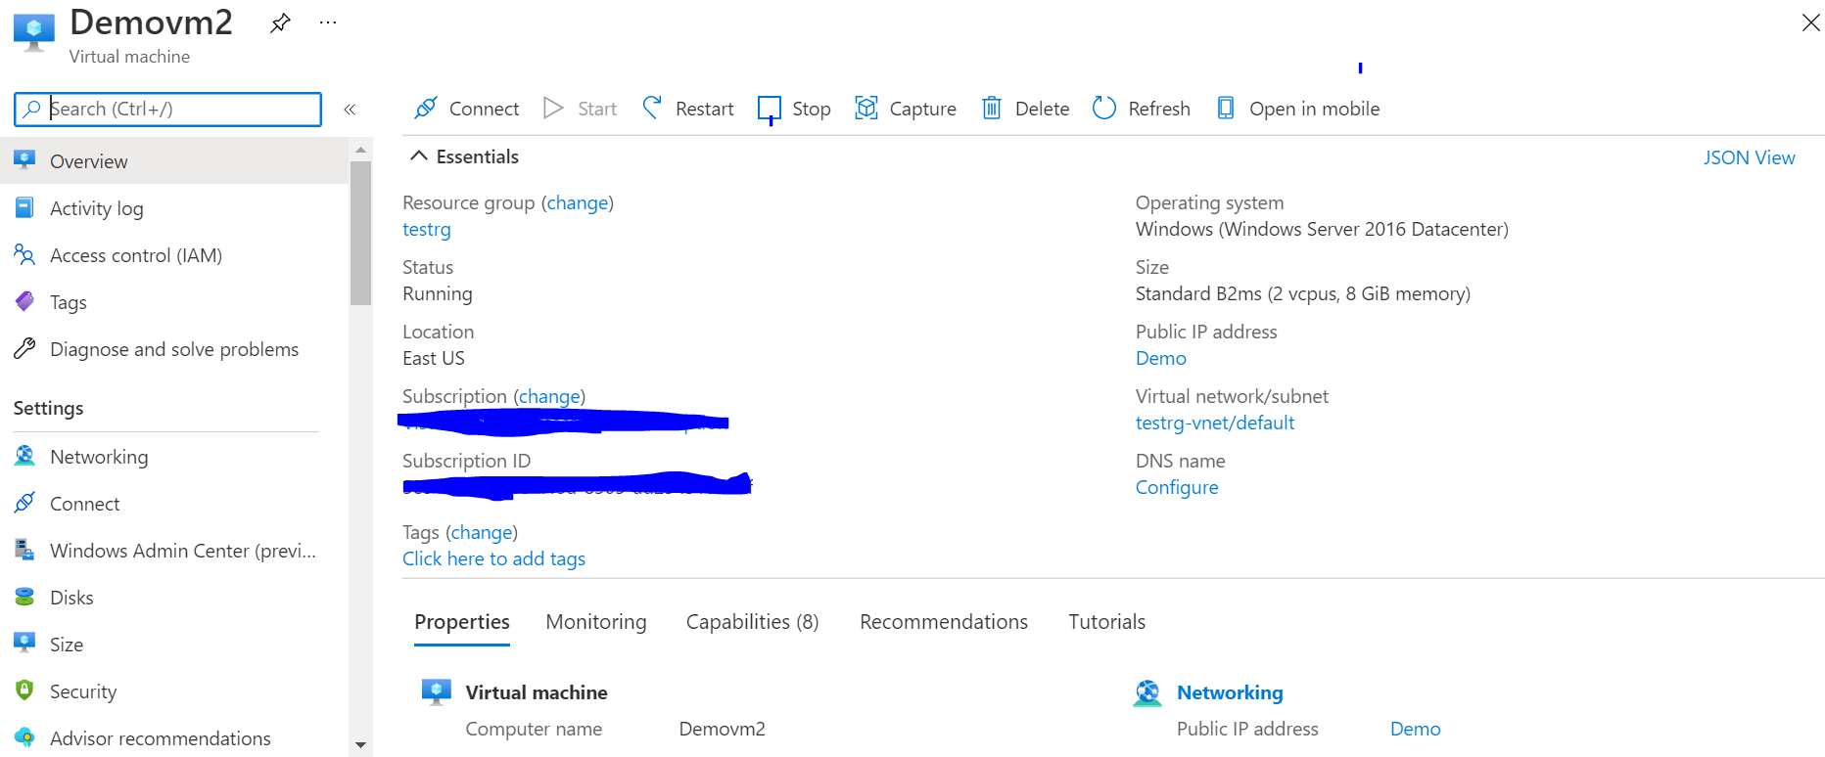

1. Created two load balancers(Internal & Public). And configured backend pools, health probe and loadbalancing rules.
2. **Why we need both internal and public load balancer:** Public load balancer will load balance internet traffic to our Virtual machines. It provide outbound connections for virtual machines inside our Vnet. And internal Load balancer will balance the traffic from within the Vnet.

**Configured public Load Balancer:**

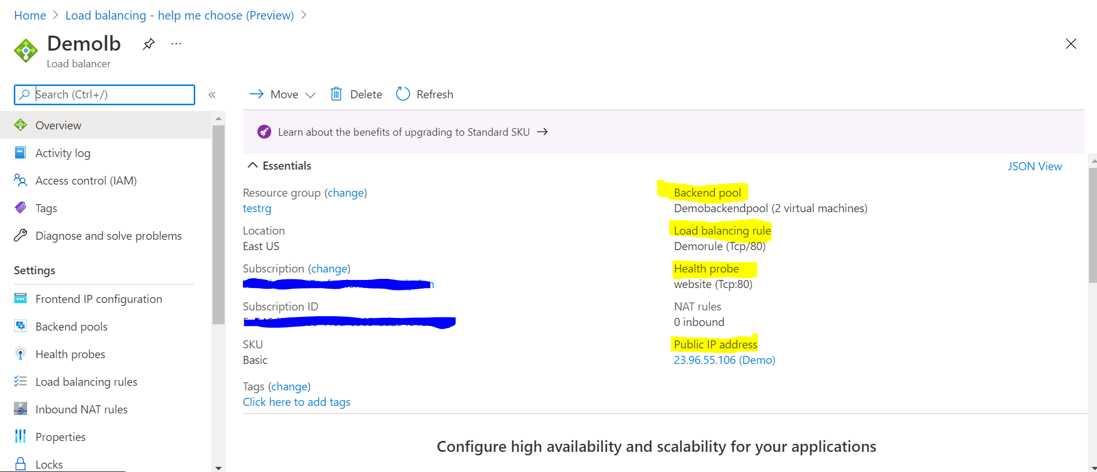

**Configured Internal Load balancer**

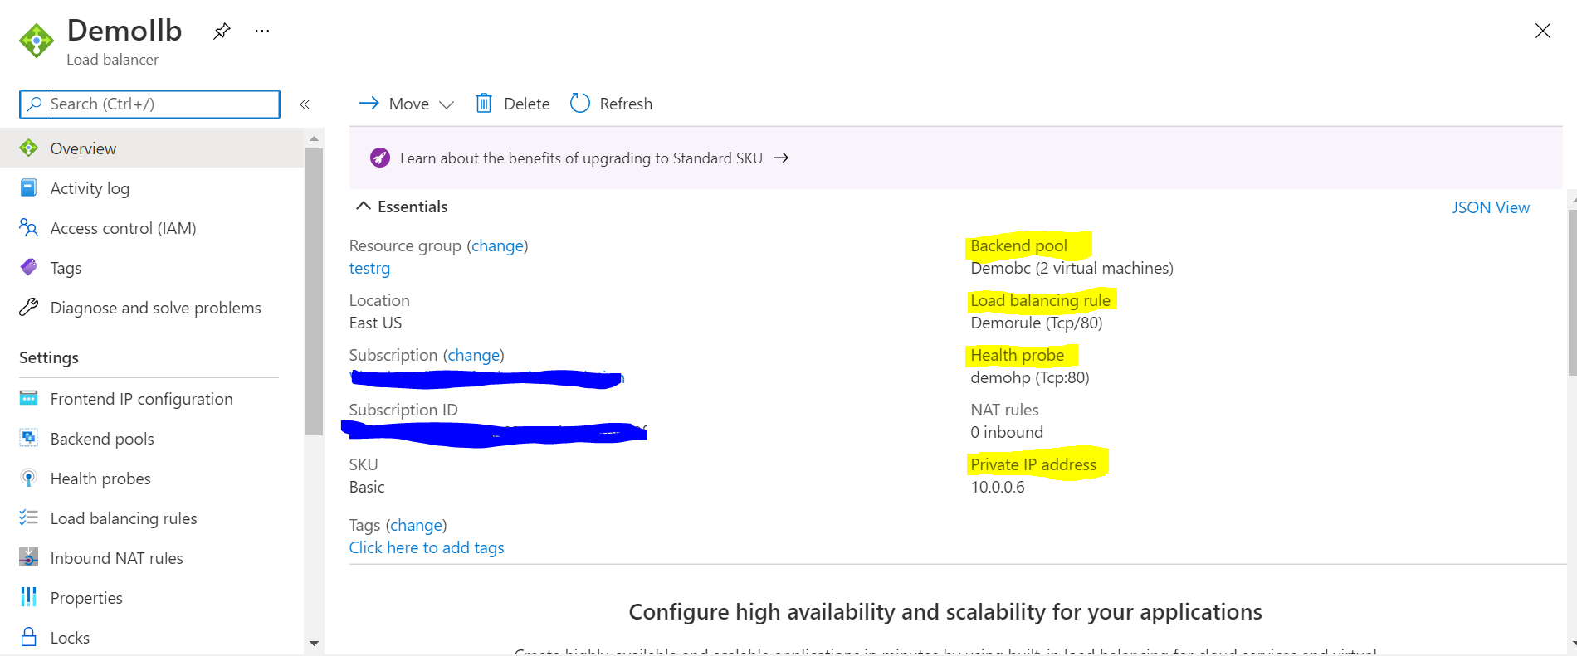

**Configured DNS for the public IP**

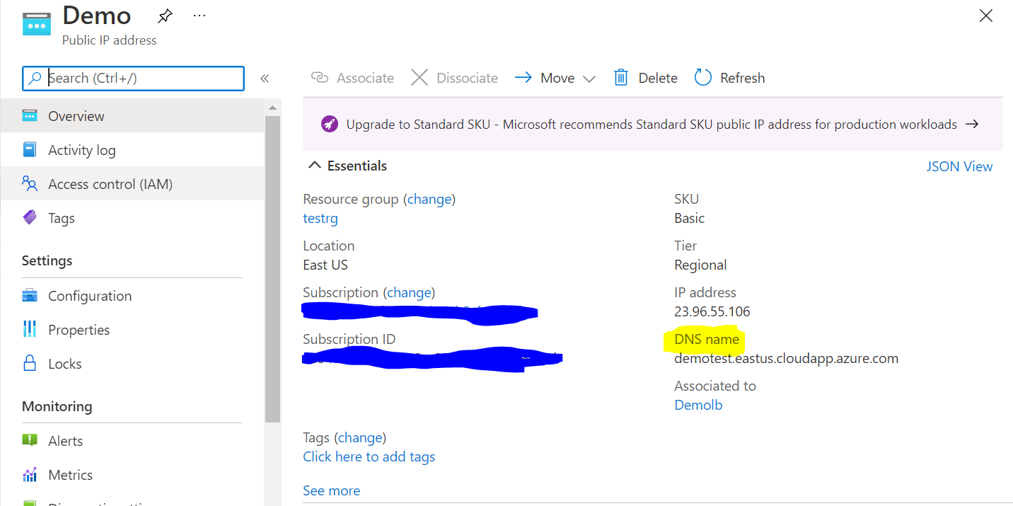

1. Deployed SQL DB along with failover group for high availability. If primary region goes down, we can failover it to another region.

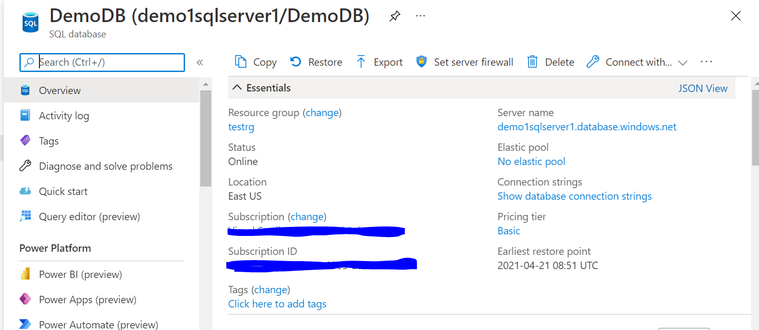

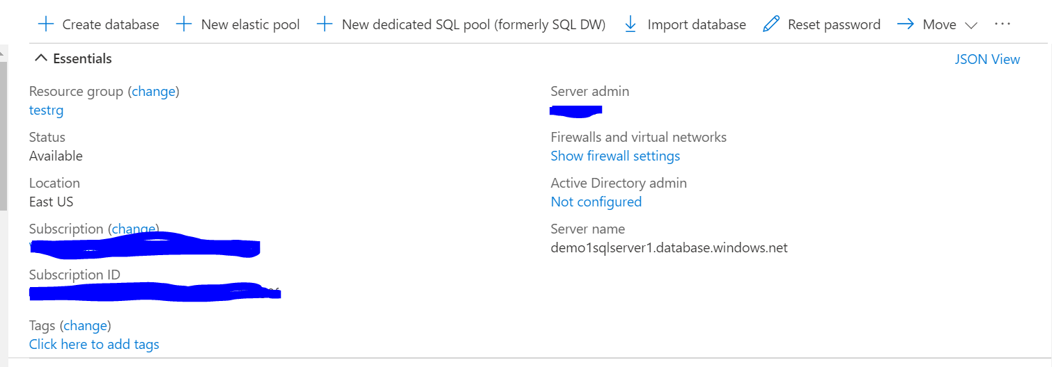

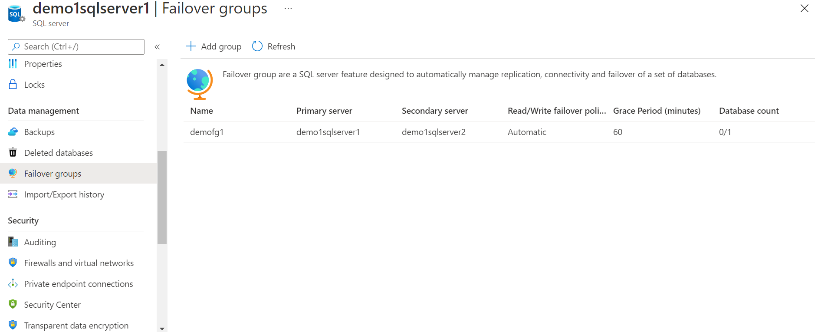

1. Installed IIS web server on both Virtual machines (Demovm1 & Demovm2).

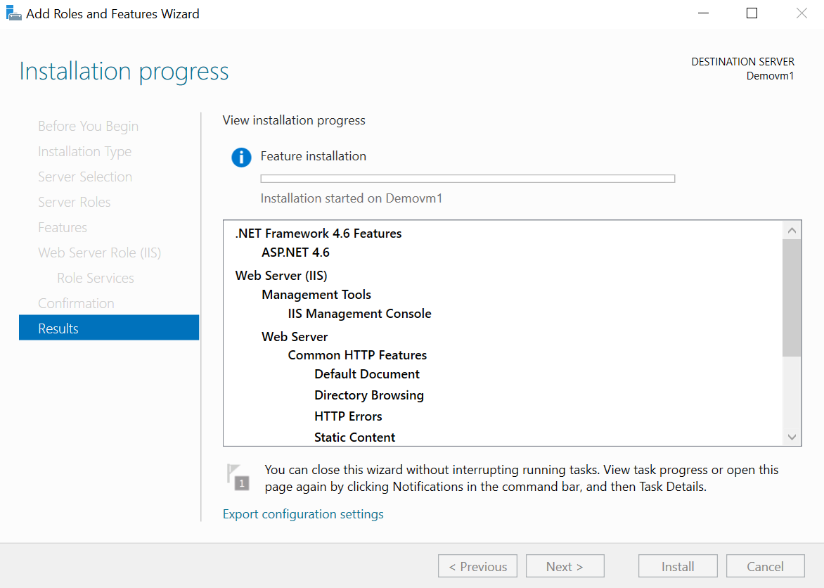

1. Once installation is done successful. Tried to access the web in the browser using public DNS. And IIS web server page is loaded successfully

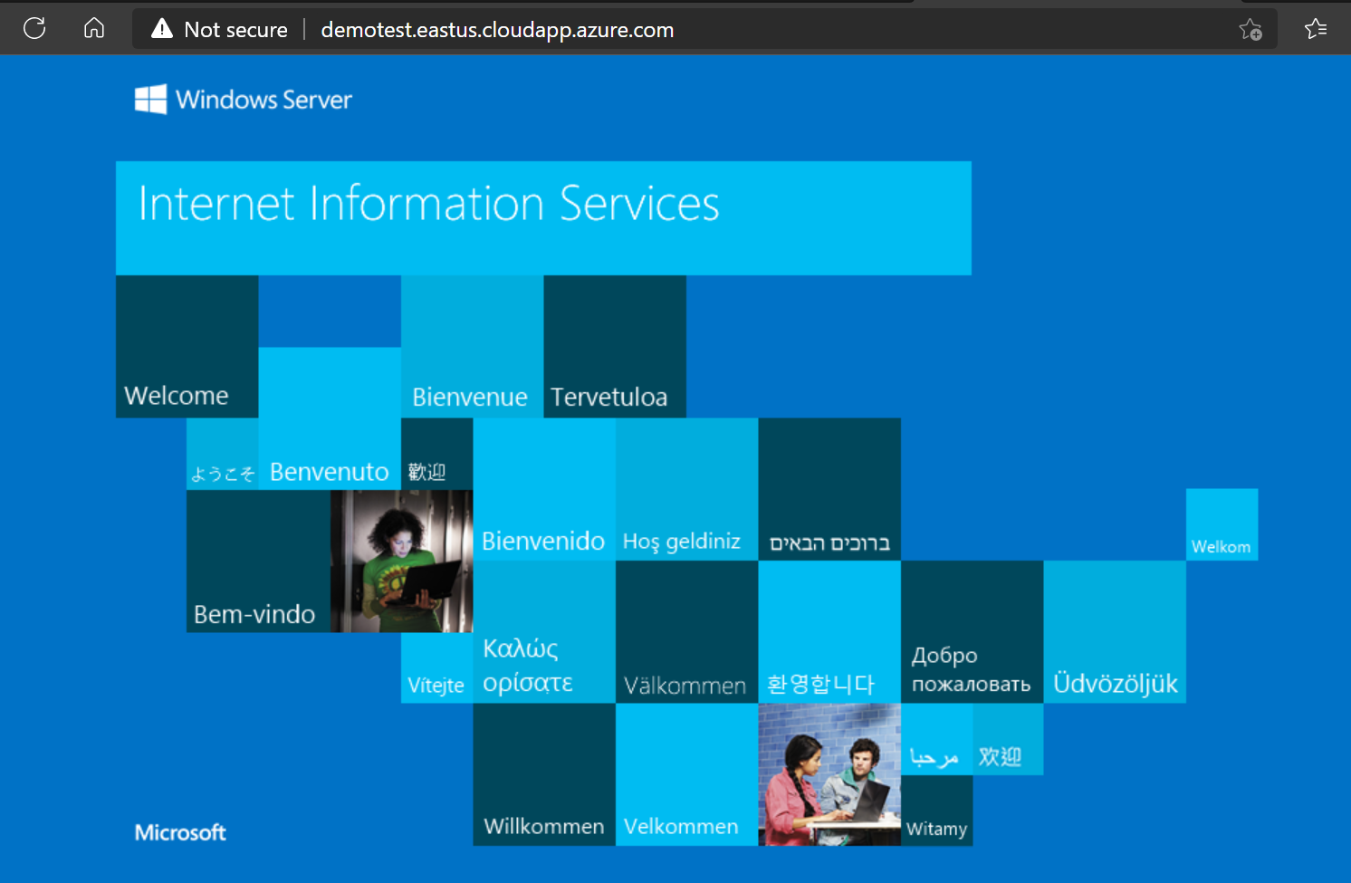

1. Stopped/deallocated the first VM(Demovm1) and tried to access the second VM’s using public DNS and able to open the IIS server page successfully. Hence traffic is flowing to second VM when first VM was having issues or stopped etc.
2. Below is complete list of resources deployed in azure for 3-tier environment.

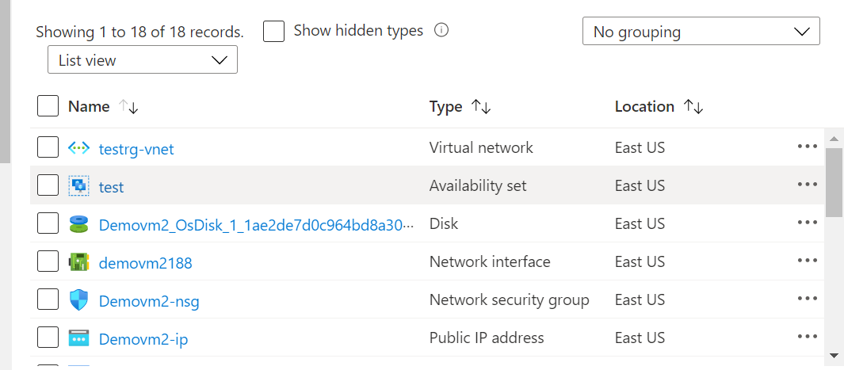

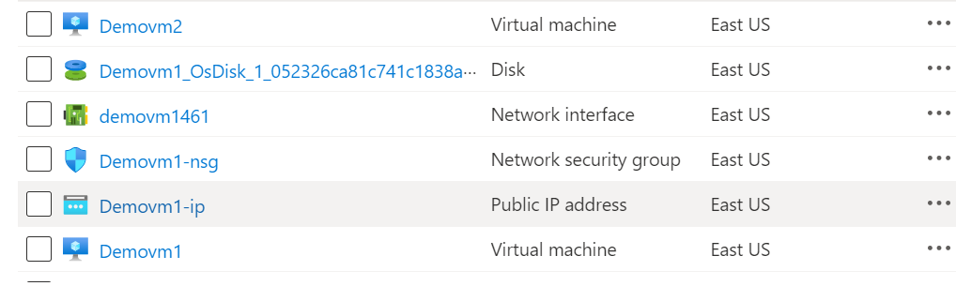

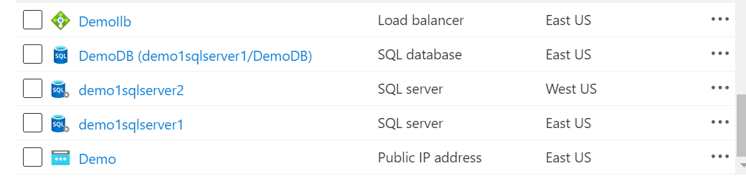

**Note**: Please let me know if live demo needed then I can prepare this environment over the call/screen share session.